3. Family Matters
Choreographed by Lisa Skates of Simply Social Dance
Dancers: Amanda and Jim Trott
Music: Crosby, Stills, Nash and Young

4. Eat My Words
(aka Pronouns for Dinner)
Choreographed, written, and performed by Claire Porter
Music: TBA

5. Say Hello to the Fool
Choreographed by KaTonya Rochester. Danced with Richard Field
Music by Steals Brothers Melvin & Mervin. Sung by Russell Thompkins Jr.

6. Golden Hour
Choreographed by Allison Brown
Dancers: D.J.& Sarai Bayon, Lauren Cabelo, Emily Gomez,
Cataleya Montoya, Lavender Rivers, Ella Sutherland
Music: Novox, Karaokey & Tazzy

Special Thanks to all the dancers, volunteers, alumni, and friends who continue to support our mission through donations of time and money!

Center for Modern Dance Education Non-Profit Organization founded 1962
84 Euclid Avenue, Hackensack, NJ 07601 201-342-2989
info@cmde.org, www.cmde.org
Artistic Director: Elissa Machlin-Lockwood
Arts Administrator: Bonnie Hyslop
Development Coordinator: Janice Rollo
Marketing: Lija Znakina (Rhubarb Crew)
Program Assistant: Corinne Reilly-Ferretto

BOARD OF DIRECTORS: President: Audrey Goodman, Treasurer: Barry Rochester, Secretary: Sharon Silow-Carroll, Trustees: Antonia Diaz, Richard Field, Danielle Hartman, Ruth Bauer Neustadter, Jamie Sporn, Ursula Pelle
ARTISTIC ADVISORY BOARD: Joanne Koob-Brown, Dian Dong Chen, Cynthia Low, Claire Porter, Susan Thomasson
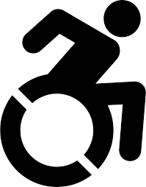
ADA ADVISORY BOARD: Karen Blumenthal, Carolyn Hayer, Amanda Trott, Lauren Valenta
CMDE's programs are made possible in part by funds from The National Endowment for the Arts, New Jersey State Council on the Arts, Levitt
Foundation, Lillian Pitkin Schenck Fund, and matching gifts from BD, Pfizer, and Tisch. CMDE is designated as a Peace Site by New Jersey Peace Action

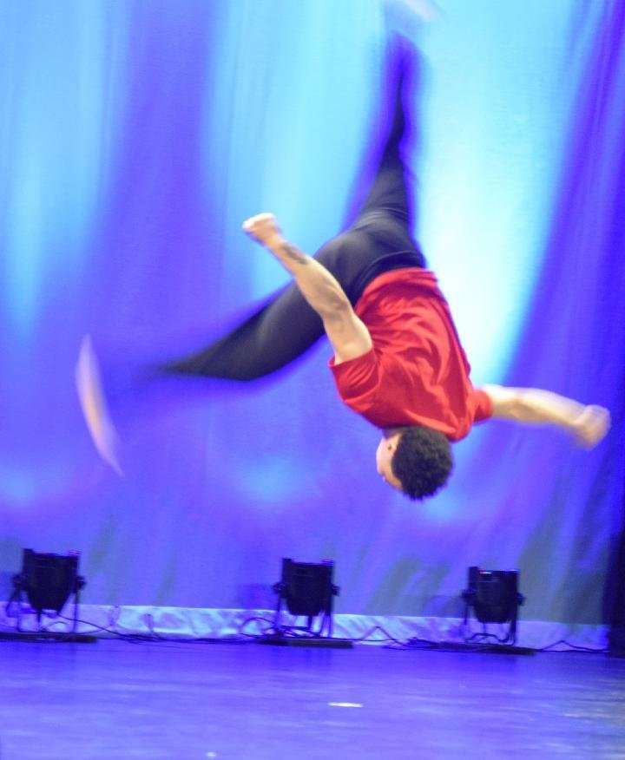
CMDE
Super Studio
Danceathon Day
June 1st 2024
3 different shows
11:15
1:00
2:30

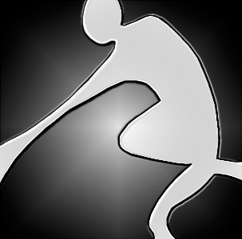

African Dance Warm up for Everybody 11:00

First Show 11:15

1. Sunu /Celebration of Life
Choreography and music: Yahya Kamate
Dancers: Mila Vanden Abeele, Geraldine Antonio, Angelina Bayon,
Karolyn Jerez, Lianna Mutabazi, Olivia Wilson, Aria Zaken, Azmia Zongo

2. From Africa to Hackensack
Choreography and music: Yahya Kamate
Dancers: Mila Vanden Abeele, Daniel Bayon, Sarai Bayon,
Kamalia Lespinass, Cataleya Montoya, Lianna Mutabazi,
Lavender Rivers, Ella Sutherland, Azmia Zongo

3. Lamban Foundation of Life
Choreography and music: Yahya Kamate’
Dancers: Idalize Garcia, Michelle Plumber, Jamie Sporn,
Brenda Thomas, Sasha Thompson

4. Get Back Up Again!
Choreographed by Allison Brown. Assisted by Amanda Trott
Dancers: Geraldine Antonio, Emmy Anderson, Angelina Bayon, Amelia and Myra Brown-Warren, Karolyn Jerez, Kamaria Lespinass,
Music: Trolls soundtrack by Anna Kendric

5. Trio
Choreographed and Danced by Azmia Zongo,,Llianna Mutabzi, Mila Vanden
Music:TBA

6. Beautiful things
Choreographed by Alison and Silinea Hilliard
Moving Experience Dancers: Chris Hayer, Megan Farrell, Chesne Valenti
Music : Benson Boone

7. Golden Hour
Choreographed by Allison Brown
Dancers: D.J.& Sarai Bayon, Lauren Cabelo, Emily Gomez,
Cataleya Montoya, Lavender Rivers, Ella Sutherland
Music: Novox, Karaokey & Tazzy

Modern Moves Open Class for Everybody 12:30

Second Show 1:00

1.Ready to Connect
Choreographed by Elissa Machlin-Lockwood
Dancers: Kevin Cooper, Arielle Goldman, Audrey Goodman, Sara Muller,
Ruth Bauer Neustadter, Liza Ricco,
Nellie Rojas, Sharon Silow-Carroll, Amanda Trott
Music: Stevie Wonder, Higher Ground, "Playing for Change"

2. Best Day of My Life
Choreographed and directed by Amanda Trott.
Assisted by Arielle Goldman and Nellie Rojas
Moving Experience Dancers: Megan Farrell, Daniela Navarro
Music: American Author

3. Solo
Choreographed and Danced by Kevin Cooper
Music:TBA

4. Family Matters
Choreographed by Lisa Skates of Simply Social Dance
Dancers: Amanda and Jim Trott
Music: Crosby, Stills, Nash and Young

Move Your Chi Tai chi Open Class Everybody 2:00

Third Show 2:30
1. Get Busy
Choreographed by Jayren Madera
Dancers: Angelina, D.J. & Sarai Bayon, Aaliyah Fulmore, Emily Gomez,
Cataleya Montoya, Lavender Rivers, Ella Sutherland
Music by Sean Paul

2. In the Family of Things
Choreographed and performed by Susan Thomasson
Music: Bobby McFerrin. Text: “Wild Geese” by Mary Oliver

